When your computer first boots, this window will appear in the center of the screen.
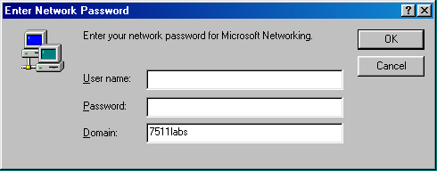
- Make sure that the Domain: is 7511labs. It should already be set to that.
- The User name: could be any value. You need to change it to YOUR User name. Your user name has two parts. Your PERIOD NUMBER and your COMPUTER NUMBER.
For example, if it is period 4 and you are sitting at computer 5, your User Name: will be 04-05. Notice that both numbers must be two digits long and that there is a dash between them.
If it is period 1 and you are sitting at computer 27, your User name will be 01-27.
In the case that you are sharing a computer with another student, you will still need a unique User name. In that case, the teacher will assign you a number in the range of XX-33 to XX-50.
- Write your User name on this line .
- The first time that you sign on you will not have a password. Do not enter a password. Leave the Password blank for now.
- Click OK
- New users have a BLANK password. This password is already expired. When you see this window, click OK.
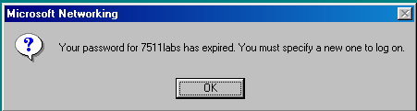

- You will then be prompted for a new password.
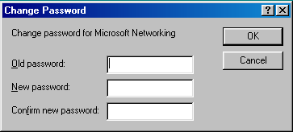
Do not enter anything for the Old password. Instead click on New password: and enter your password. Passwords should be at least 8 characters long and include at least 1 number and 1 letter. When you type your password, it will not appear. Instead you will see a series of asterisks(******).
Write your password on this line:
Do NOT let anyone, except your teacher, see this password. You are responsible for all actions that occur when a computer is logged on with your password.
Type the exact same password in Confirm new password:
- Click OK.

