Creating and Using a Personalized Drop Box
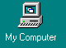
1. Open your personal folder on the server.
- Click on My Computer

b. Find the Student_data on ‘7511_prog_serve’ icon, the
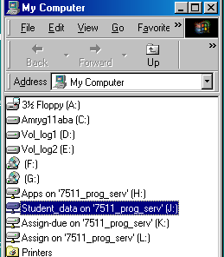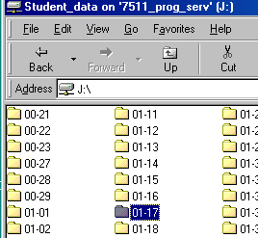double click to reveal a list of all student folders.

c. Find and open YOUR personal folder
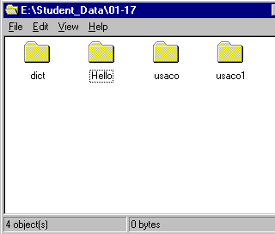

2. In your personal folder create a NEW folder. Name it with the following code:
K - single letter (other teachers will use a different letter)
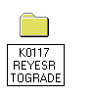## - period number (2 digits 00-18)
## - Your class number (2digits 01-99)
- 1 space
% % - Last Name
% % - First Initial
- 1 space
TOGRADE
Thus, if Robert Reyes had class number 57, he would name the folder
K0557 REYESR TOGRADE

(Be SURE that your folder name is named just like this. Work submitted in a folder named in any other format will be filed in the wrong location and will not be graded.
3. Create a SHORTCUT to this folder by RIGHT-CLICKing on the folder and choosing Create Shortcut.
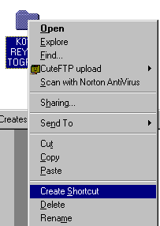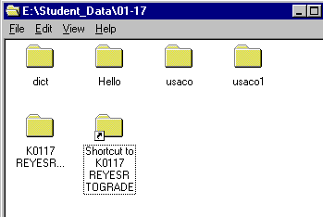

There should now be two new folders.

3. To submit work for grading, put it and all support files into the TOGRADE folder.
- Create a text file with a list of all work submitted and put it into the TOGRADE folder. Name the text file GRADES.TXT
- When you are ready to submit work. Press and hold the control key and drag the shortcut folder to the class drop box. (This will copy the SHORTCUT) I will be able to access YOUR folder through this shortcut.
4. The assignment will be graded IN this folder. You can check for your grade in this folder by opening the GRADES.TXT file.
Create a Short Cut to the Drop Box and/or Assign box on your Desktop

(These should already exist on your desktop. If they do, disregard this page)
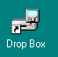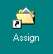
To create Drop Box

1. Double Click on My Computer.

2. Right Click on the Assign-due on ‘7511_prog_serv..
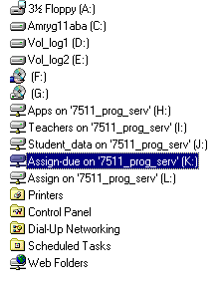

3. On the drop-down menu, chose Create Shortcut

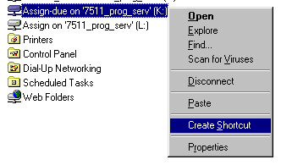

4. Since a drive shortcut cannot be copied in the folder, you will be prompted to place it on the desktop. Click Yes.

5. Change the icon from a Network Drive Icon to a Shortcut Folder Icon and the title to Drop Box.

Creating an Assignment Box

Repeat the previous 5 steps, but instead, make a shortcut to Assign instead of Assign-due
Assignment 1: Drop Box

Create a document in NOTEPAD consisting of your assignment header.
02
#17
Smith, Humberto
August 27, 2001
GRD3: Network Verification

Save the file IN YOUR NETWORK folder, with a name similar to your drop box name:

K0557 REYESR NETVER

Drag this file to the dropbox for grading.

