Cornell Notes

The Cornell method of note taking offers several advantages. It results in more organized notes. It allows students to quickly identify key words and key concepts from a lecture. The notes can easily be used as a study guide for exam preparation. The arrangement of information is aesthetically pleasing and easy to scan, making it easy to locate particular pieces of information. The strategy may be adapted to a number of presentation formats.
Directions for using the Cornell method are as follows.
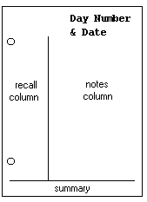  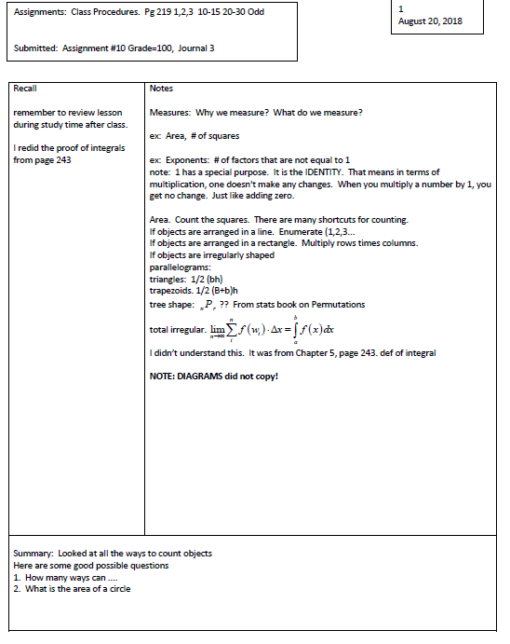  springssoft.com | - Divide the paper  - Use loose leaf notebook paper and write on one side of the page only.  - Divide the paper vertically by drawing a line from top to bottom about 2" from the left side of the page.  - Documentation  - Write Date and Page Number on the top right corner of each page during initial SETUP.  - Record notes  - During lecture, record the main ideas and concepts on the right side of the page. This is the notes column.  - Rephrase the information in your own words before writing it down.  - Record tracking information when you don't understand or can't follow. (Ask questions to slow teacher down if necessary)  - Avoid writing in complete sentences; use symbols and abbreviations instead.  - Review and Clarify Record DATE/Time for each session.  - As soon after class as possible, review the notes in the right column and clarify any ambiguous information.  - Compare the information with the book and/or other students' notes.  - Then pull the main ideas, concepts, terms, places, dates, and people from the right column and record them in the left-hand recall column.  - Summarize  - Prepare a summary of the lecture material and record it at the end of the notes.  - The summary may be in sentences or short phrases. It should include only the main ideas from the lecture.  - Study  - Use both sections of the notes to prepare for quizzes and exams.
TOPIC | Day Number  Date
----------------2 1/2”---  In this section:  Reduce ideas and facts to concise jottings and summaries as cues for Reciting, Reviewing, and Reflecting. | ------------------------------6”------------  In this section:  Record the lecture as fully and as meaningfully as possible.
The format provides the perfect opportunity for following through with the 5 R's of note-taking. Here they are:
1. Record. During the lecture, record in the main column as many meaningful facts and ideas as you can. Write legibly.
2. Reduce. As soon after as possible, summarize these ideas and facts concisely in the Recall Column. Summarizing clarifies meanings and relationships, reinforces continuity, and strengthens memory. Also, it is a way of preparing for examinations gradually and well ahead of time.
3. Recite. Now cover the column, using only your jottings in the Recall Column as cues or "flags" to help you recall, say over facts and ideas of the lecture as fully as you can, not mechanically, but in your own words and with as much appreciation of the meaning as you can. Then, uncovering your notes, verify what you have said. This procedure helps to transfer the facts and ideas of your long term memory. Work with a friend-record Date and Time.
4. Reflect. Reflective students distill their opinions from their notes. They make such opinions the starting point for their own musings upon the subjects they are studying. Such musings aid them in making sense out of their courses and academic experiences by finding relationships among them. Reflective students continually label and index their experiences and ideas, put them into structures, outlines, summaries, and frames of reference. They rearrange and file them. Best of all, they have an eye for the vital-for the essential. Unless ideas are placed in categories, unless they are taken up from time to time for re-examination, they will become inert and soon forgotten. Use your Journals for reflection. Record Date and Time.
5. Review. If you will spend 10 minutes every week or so in a quick review of these notes, you will retain most of what you have learned, and you will be able to use your knowledge currently to greater and greater effectiveness.

Generate Questions  Approach the lecture notes as a series of answers to questions. Translate the answers into questions, recording the questions in the left column (if the Cornell format is used) or on flash cards (with the answers on the back). If you can't think of a question for a section of notes, put a "?" in the margin and seek clarification from the instructor or book.  Write the questions as soon after class as possible. If you generate questions while the information is still fresh, you'll find that the process of asking questions helps you focus on the essential material. Each time you go to lecture, your notes will become increasingly more organized. You won't have to work at organizing the notes. Since question-asking helps you understand things more clearly, you'll begin to anticipate the questions as the instructor shifts topics.  Write questions for all information recorded in the notes: names, terms, concepts, dates, numbers, symbols, formulas, and illustrations. | 