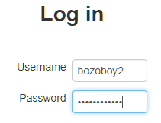
Instructions for Updating your UserName and Information in Moodle

For some reason, Moodle sorts by FIRST name. Since most programs sort data by LAST name (surname), names will have to be entered in reverse order. (Put your FIRST name in the SURNAME box and your LAST name in the FIRST name box)
Step-by-Step instructions
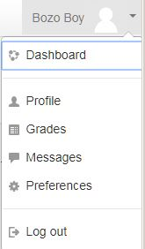
1. Log on to Moodle https://springssoft.com/moodle
2. Log into your course.
3. Click on your name/image in top right hand corner and
select Preferences.
3. From the Preference Screen, click Edit Profile
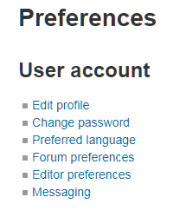

4. Here you can edit your name. The number is associated with your school number. (see below)
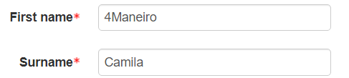
In this example, the student belongs to Doral Academy High School.
1-3029, 2-6030, 3-7009 and 4-7020

Check that your email is correct.

SET City/Town: DORAL2028
Note: the DATE is your GRADUATION YEAR. This student will graduate in 2028

Students NOT from the United States will be automatically deleted. Deleted Students LOSE ALL WORK!

Scroll down to OPTIONAL
- Fill in your student ID number
- For Institution use the same entry as you did for City/Town. Ie. DORAL2028
- For DEPARMENT enter your school ID. i.e. 3029, 6030, 7009, or 7020
- Enter information for PHONE, Mobile phone and Address.

A grade will be assigned when all this information is correctly entered.

