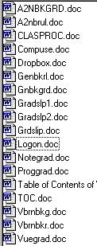Algebra Notebook Grading Sheet

Algebra Notebook Specifications

Class Procedures

Miami Springs Computer Use Policy

Creating and Using a Personalized Drop Box

Geometry Notebook Specifications

Geometry Notebook Grading Sheet

Grading Policy Math/Computers (Sign and Return)

Grading Policy Math/Computers (Keep for Records)

Sample Grade Slip

Creating a Personal Password and Account

Notebook Grading Sheet

Non OOP Program Grading Sheet

Blank Table of Contents

Visual Basic Runbook Specifications

Visual Basic Runbook Grading Sheet

How to View Current Grades on the Internet

