Adding *.pdf Textbook Chapters to IPAD

1. Start ITUNES
2. Connect IPAD to computer via USB cable. Wait for device to show in ITUNES.
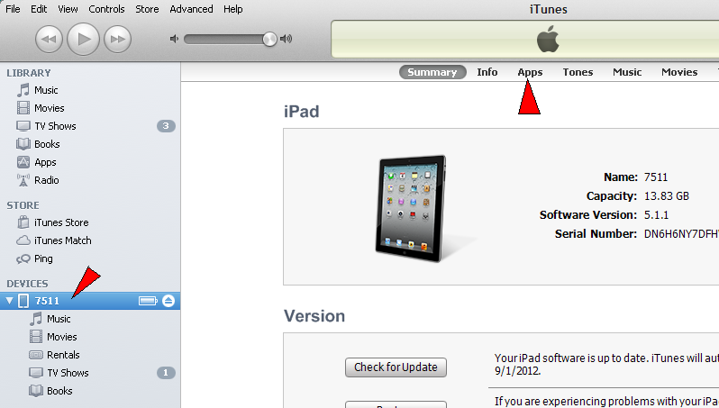
If the DEVICES name is choosen, the IPad info screen is displayed. In the middle of the top of the info bar, is the Apps button..

4. Click on the Apps button to display information about your apps. This will display the Sync Apps window.
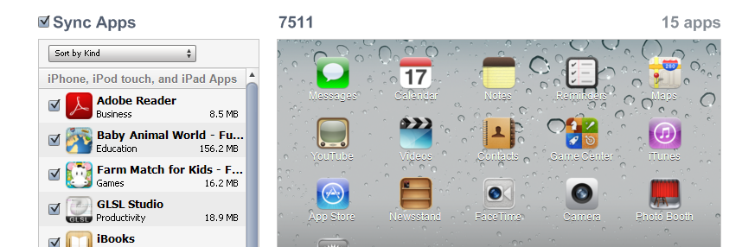

5. You must SCROLL DOWN to find the File Sharing data area for these apps. I have selected the Adobe Reader app. The available files are displayed in the window to the right.
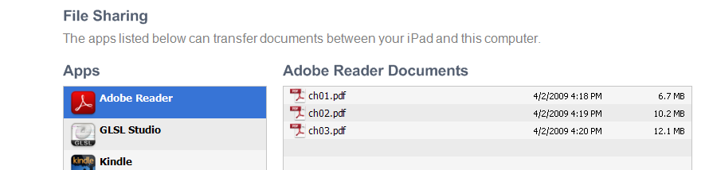
6. To ADD a file. Drag it from your computer to this window.\
7. To DELETE a file. Highlight the file in the window and press the DELETE key on your COMPUTER!!. (There is no delete function on the IPad itself)

