Nu Alpha Theta Invitational Geometry Team Round
24 March 2007 Solutions

1. Looking at Primitive Pythagorean Triples with one side length a factor of 24 shows (3,4,5), (5,12,13), (7,24,25), (8,15,17), (12,35,37). Note that (3,4,5) spawns two different right triangles (24-32-40 and 18-24-30), while the rest spawn only one. So the total is 6.
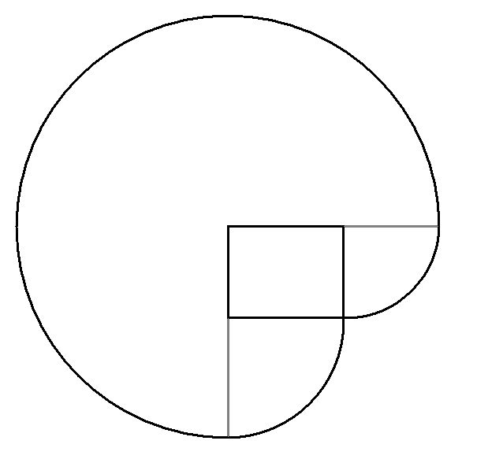
2. 360/n, where n is the number of sides, gives the exterior angle measure. The supplement of the exterior angle measure is the interior angle measure. So 180 – 360/n, for n = 3, 4, 5, 6, 8, 9, 10, and 12 gives 60 + 90 + 108 + 120 + 135 + 140 + 144 + 150 = 947.
3. The cow can roam over 3/4 of a circle of radius 27,
one-fourth of a circle with radius 15, and
one-fourth of a circle with radius 12.
The figure gives an idea of the shape.
Knowing powers of 3 or some quick arithmetic gives
(3/4)(27²π) + (1/4)(225π) + (1/4)(144π) = 639π.
4. Label the side connecting the tops of the stakes as x.
Call the shorter remaining side a and the longer b.
Form a right triangle with x as the hypotenuse with one leg lying
on the tall stake and the other parallel to the ground, and find x = $\sqrt{\text{225}+\text{144}}=3\sqrt{\text{41}}$.
We can find a and b by using similar triangles formed by the stakes and point X. Now call the distance from X to the base of the longer stake d, and call the distance from X to the base of the shorter stake c. By right triangles, a+d=17 and b+c=25. By similar triangles, a/d=c/b=8/20=2/5. This gives 5a=2d and 5c=2b. Solving each set of simultaneous equations gives a = 34/7 and b = 125/7. Adding the side lengths gives $3\sqrt{\text{41}}+\text{159}/7$.
5. Perimeters are easy, they’re just the total number of sides: 4+6+8=18. Area of the square is simply 1, area of the hexagon is $6⋅\frac{1^{2}\sqrt{3}}{4}=\frac{3\sqrt{3}}{2}$, area of the octagon is $\frac{1}{2}(\frac{1+\sqrt{2}}{2}⋅8)$ = $2+2\sqrt{2}$. Add it all together and you get $\text{21}+\frac{3\sqrt{3}}{2}+2\sqrt{2}$.
6. MD is the hypotenuse of a right triangle whose other legs can easily be found to be 1 and $1+\sqrt{2}/2$. Pythagorean Theorem shows the square of MD to be $5/2+\sqrt{2}$. Multiply that by pi and you have the circle’s area = $(5/2+\sqrt{2})π$.
7. Let a and b be half the diagonals, where 2a is the shorter diagonal. 2a+2b=28, so a+b=14. We also know that a²+b²=100. Some quick algebra or intuition shows a=6 and b=8. So the area of the rhombus is (2)(6)(8)=96.
8. Knowledge of parallel lines and similar triangles should be enough to see that triangles ACE, FCL, GIL, and GAH all have the same area as EFIH, and the area of each is 1/5 the area of the large square. Thus, EFIH’s area is x²/5.
9. The area is just ADEH’s area minus the areas of BCJ, DKE, GLF, and AIH. ADEH’s area is 49, BCJ and GLF both have the same area, and DKE and AIH have the same area. Taking one half base times height and doubling it in each triangle gives 35/4+63/20=119/10=11.9, and subtracting from 49 gets 37.1, or 371/10.
10. The height from PS to QR is $4\sqrt{3}$, so forming particular right triangles with the diagonals as their hypotenuse gives us PR² = ${\text{13}}^{2}+(4\sqrt{3})^{2}=$217. Also, QS² = $5^{2}+(4\sqrt{3})^{2}=$73. Plugging into the final expression gives 217-73=144, square root of 144 is 12.
11. Triplets that are right are: (7, 24, 25), (8, 15, 17), (9, 40, 41), (16, 63, 65), (8, 6, 10), (8, 31.5, 32.5). That makes 6 of them. Note that triplets for which a²=b+c, and c–b=1 both hold are right, and this problem becomes easier.
12. Call the points A, B, and C, respectively. AB=15, BC=20, AC=25. Note that these lengths form a right triangle, whose area is .5(15)(20)=150.
Since they form a right triangle, the hypotenuse will be a diameter of the circle, so the radius is easy to find: just divide the hypotenuse by 2 = 25/2. Circle’s area is 625π/4.
The three parallelograms will simply have twice the area of the triangle, so each has an area of 300.
Summing these gives 450+625π/4.
13. The quick frustum volume formula is $V=h⋅\frac{A_{1}+A_{2}+\sqrt{A_{1}⋅A_{2}}}{3}$. Plugging in gives 380.
14. Drawing out truth tables shows that the statements build on each other. The the expressions’ truth values are True, True, False, False, True, False, False, respectively, so three are true.
15. Each plane forms a circle of intersection with the sphere. These circles have radius $5\sqrt{3}$. The rest of the problem breaks down to this: in each circle, a chord passes 5 units from the center. The length of the chord is the answer to the problem, so simple right triangle relationships show that the chord’s length is $\text{10}\sqrt{2}$.

