1. Find the area of a triangle with height 6 and base 7.
A. 42 B. 14 C. 35 D. 21 E. NOTA

2. The internal and external tangents of two nonintersecting circles are the same length.
A. True B. False E. NOTA

3. An angle’s complement is$3x−\text{41}$ degrees, and its supplement is $8x−\text{36}$ degrees.
What is the angle’s measure in degrees?
A. 17 B. 10 C. 80 D. 100 E. NOTA

4. Which of the following are enough to prove congruence between two triangles?
I. SSS II. SAS III. SSA IV. ASA V. AAA

A. I, II only B. IV, V only
C. I, II, IV only D. all of these E. NOTA

5. How many different regular polygons can form a regular tessellation in a plane?
A. 1 B. 2 C. 3 D. 4 E. NOTA

6. If you’re not a gator, then you must be gator bait. I know that I am a gator. What can I conclude?
A. I am not gator bait. B. I used to not be gator bait.
C. Gators eat gator bait. D. Gators are the best reptiles. E. NOTA

7. My wedding cake, which rests on a plate, has 2 levels, each in the shape of a cylinder, sitting one on top of the other. The top level has radius 5 inches and height 3 inches.
The second level has radius 10 inches and height 6 inches.
If the levels are stacked on top of each other and on a serving dish, then the whole exposed surface of the cake is covered in icing that costs half a cent per square inch, what is the price of the icing?
A. 125π cents B. 250π cents
C. 275π cents D. 500π cents E. NOTA

8. Segments AB and CD are chords of a circle, and they intersect at point K. If AK = x + 4, BK = x + 5, CK = 1 – x, and DK = x + 7. What is the value of x?
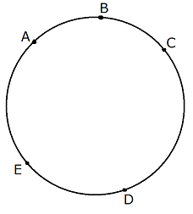
A. B. 3 C. 12 D. -1 E. NOTA

9. In the circle, CE is a diameter, arc AB measures 50 degrees,
arc BC measures 40 degrees, and arc DE measures 70 degrees.
Find the measure of arc DAC minus the measure of arc ACE.
A. 0 B. 50
C. 20 D. -20 E. NOTA

10. Triangle JDW is similar to triangle MRP. The area of JDW is 36 and MRP’s area is 4. If JW = 9, what is the length of MP?
A. 1 B. 2 C. 3 D. 4 E. NOTA

11. A frictionless billiard table with sides of length 4 and 7 has holes in each corner and halfway across the longer sides. If a ball is hit from a corner (next to the pocket) at a 45 degree angle to the sides, how many times will the ball hit the sides of the table before it enters one of the pockets?
A. 5 B. 6 C. 9 D. 11 E. NOTA

12. A triangle has side lengths of $1+n^{2}$, $−1+n^{2}$, and $2n$, where n is an integer greater than 1. How many of the following MUST describe this triangle?
I. Scalene II Isosceles III Right
IV Obtuse V Acute VI Equilateral

A. One B. Two C. Three D. Four E. NOTA

13. One boat sets sail from port at an angle of 60 degrees north of east at the same time as a second boat sets sail from the same port due east. The first boat sails at 24 miles per hour and the second boat sails at 12 miles per hour. How far apart are the boats after 2 hours of sailing?
A. $\text{36}\sqrt{3}$ B. 72 C. 12 D. E. NOTA

14. Segment KL is externally tangent to circle J at K and circle M at L. JK=9, ML=1, JL=$3\sqrt{\text{34}}$.
How far apart are the circles’ centers?
A. $3\sqrt{\text{34}}$ B. 17 C. 15 D. 8 E. NOTA

15. A dokergon is any polygon which satisfies the following criteria:
I. It has four sides
II. It can be inscribed in a circle
III. Its area is equal to half the product of its diagonals
For the purposes of this test, let a kite be defined as a quadrilateral with two adjacent sides of length a and the other two sides of length b. Which of the following is the most specific set to which the set of dokergons belongs?
A. Squares B. Rhombi C. Kites D. Quadrilaterals E. NOTA

16. Complete the following analogy:
Euclidean geometry : line :: Spherical geometry : ___________
A. Great Circle B. Diameter
C. Circle D. Radius E. NOTA

17. Triangle ABC has AB=20, BC=13, and CA=11. Find the length of the altitude to .
A. $\frac{\text{33}}{5}$ B. $\frac{\text{44}}{5}$ C. $\frac{\text{56}}{5}$ D. 7 E. NOTA

Use this information for questions 17 and 18
A regular hexagon of side length 1, ABCDEF, rests with segment AB on line k, and A is left of B. ABCDEF is “rolled” along k so that it rotates clockwise about B until segment BC is on k, then it rotates about C in the same way, then D, E, F, and A, until segment AB is again on k.

18. What is the distance between the starting point of A and the final point of A?
A. 0 B. 1 C. 6 D. 7 E. NOTA

19. What is the total distance traveled by point A along its path?
A. 3π B. 6
C. $\frac{π}{3}(3+\sqrt{3})$ D. $\frac{2π}{3}(2+\sqrt{3})$ E. NOTA

20. Any oblique cone has varying lateral heights. In a particular oblique cone, the shortest lateral height is 3 and the longest lateral height is 4. Its base is a circle with radius 2.5. What is the cone’s volume?
A. 5π B. $\text{12}5$ C. 15π D. 10π E. NOTA

21. A balance scale is arranged so that a solid gold tetrahedron (regular triangular pyramid) of edge length $π$ feet is on one side of the fulcrum and a solid gold sphere of radius $π2$feet is on the other side of the fulcrum. The tetrahedron is $π$ feet from the fulcrum. If the balance is perfectly level, how far from the fulcrum is the sphere?
A. 2π B. $1/2$ C. $\sqrt{2}/(2π)$ D. $\sqrt{2}/2$ E. NOTA

22. A circle is inscribed in a right trapezoid, a trapezoid where two consecutive angles are right, whose parallel sides are of length 8 and 18. What is the area of the trapezoid?
A. 143 B. 144 C. 156 D. 169 E. NOTA

23. Euclid’s Elements, the most influential treatise in the history of Geometry and the most successful textbook ever written, consists of 13 books. Find the area of a circle with radius 13. A. 13π B.169 C. 144π D. 169π E. NOTA
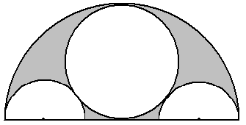
24. A circle is inscribed in a semicircle of radius R,
then two semicircles are inscribed inside
that figure to create the shape shown.
Find the area of the shaded region in terms of R.
A. $\frac{5{πR}^{2}}{\text{36}}$ B. $\frac{\text{13}{πR}^{2}}{\text{36}}$ C. $\frac{{πR}^{2}}{4}$ D. $\frac{2{πR}^{2}}{9}$ E. NOTA

25. In triangle ABC, $m∠A=\text{75}°$, $m∠B=\text{45}°$, and $\text{AB}=3\sqrt{2}$. Find the length of AC.
A. 1 B. $2\sqrt{3}$ C. $2\sqrt{6}$ D. $3\sqrt{6}$ E. NOTA

26. This figure, called the Flower of Life, is composed of overlapping circles of area $π$.
The figure is drawn to scale – all circles’ centers are evenly and symmetrically spaced.
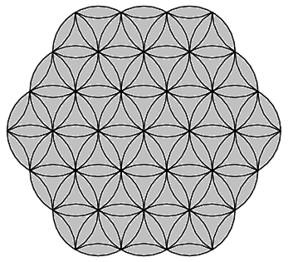
Find the area of the shaded region (i.e. the whole Flower of Life).
A. $3π+9\sqrt{3}$ B. $\frac{\text{27}\sqrt{3}}{2}$
C. $\frac{\text{27}\sqrt{3}}{2}+π$ D. $3π+\frac{\text{99}\sqrt{3}}{2}$ E. NOTA

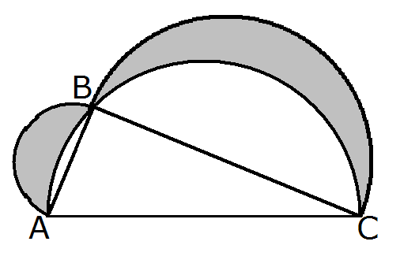
27. In this figure, a triangle has had semicircles formed with their diameters on the triangle’s sides. Note also that the triangle is inscribed in
the largest semicircle. If the area of triangle ABC is 17,
what is the area of the shaded region?
A. 17 B. $5π$
C. $7π$ D. 15 E. NOTA

28. In a circle with center O, the two chords AB and BC form an inscribed angle of degrees and the arc it intersects, AC, has measure degrees. Find the value of x.
A. 6 B. 10 C. 11 D. 42 E. NOTA

29. In right triangle with sides measuring 3, 4, and 5, a median is drawn to side of length 5. How long is that median?
A. B. C. D. E. NOTA

30. How many diagonals does a regular pentagon have?
A. 2 B. 3 C. 5 D.7 E. NOTA

