Nu Alpha Theta Invitational Geometry Individual
24 March, 2007 Solutions

1. D .5(base)(height) = .5(6)(7) = 21.

2. B A counterexample is easy to find. False.

3. C 90 – (3x – 41) = 180 – (8x – 36), solving gives x = 17, so the complement is 10, and the angle measures 90 – 10 = 80.

4. C SSA does not necessarily define a single triangle, and AAA only shows similarity, not congruence. The rest (I, II, and IV) are sufficient to show congruence.

5. C Equilateral triangles, squares, and hexagons are the only 3 regular polygons that tessellate

6. E A conclusion’s truth does not necessarily imply the hypothesis’ truth. Something else could have caused the floor to get wet, hence we have no conclusion.

7. A Both lateral areas must be added up. The bottom of layer one covers up some of layer two’s top, so that the combined area from the top of the layers is merely the area of one base of the bottom layer. Lateral areas: 2*π*5*3 + 2*π*10*6 = 150π. Area of base = π*10^2 = 100π. Add those up and you get 250π. Last, 250π*(¢0.5) = 125π cents.

8. B Check which side length is longer by raising both of them to the 30th power. This gives us that $(\sqrt[\text{10}]{\text{10}})^{\text{30}}={\text{10}}^{3}=\text{1000}$, and $(\sqrt[3]{2})^{\text{30}}=2^{\text{10}}=\text{1024}$. Hence, side length$\sqrt[3]{2}$is longer.

9. D Since CE is a diameter, arc CE = 180, so AE = 90, which means CD=180–70=110. So DAC – ACE = 250 – 270 = -20.

10. C Ratio of areas is the square of the ratios of corresponding sides, i.e. [MP/9]² = 4/36 = 1/9. Solving gives that MP must be 3.
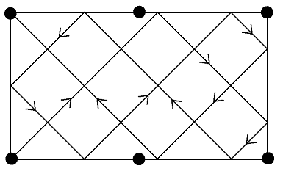
11. C Tracing out the shapes of 45-45-90 triangles
of varying side lengths gives the ball’s path as shown,
which bounces off the sides a total of nine times.

12. B $1+n^{2}$ is always the longest side (unless n = 1, in which
case there is no triangle) , so squaring gives
$(1+n^{2})^{2}=1+2n^{2}+n^{4}$, while the other two sides’
squares are $(1−n^{2})^{2}=1−2n^{2}+n^{4}$ and $(2n)^{2}=4n^{2}$. Adding those together gives
$1−2n^{2}+n^{4}+4n^{2}=1+2n^{2}+n^{4}$, so the sides always make a right triangle. Now we check to see if the two legs can ever be equal: $1−n^{2}=2n$ can be rearranged to $0=n^{2}+2n−1$, which does not give an integer solution. Hence, the triangle must be isosceles. So the two terms that must describe the triangle are I Scalene and III Right.

13. D The two ships displacements can be shown as 30-60-90 right triangles, with one pointing north and the other pointing south. The northern triangle’s hypotenuse is 48, so its leg pointing east (across from the 30 degree angle) is 24 and the north-south leg is$\text{24}\sqrt{3}$. The second boat is 24 miles east of the port, and thus is due south of the first boat. Thus the north-south leg of the right triangle is distance between the boats: $\text{24}\sqrt{3}$.

14. B Triangle JKL is right, with right angle at K. Since JL = $3\sqrt{\text{34}}$ and JK = 9, the Pythagorean Theorem tells us that KL = 15. Now draw a line through M, parallel to KL, and give its point of intersection with JK the name X. Triangle JXM has right angle at X, with XM = 15, and JX = 9 – 1 = 8. Pythagorean Theorem again tells us that JM = 17.

15. C Since dokergons can be inscribed in a circle, opposite angles must be supplementary. This rules out B. Squares and kites both satisfy III, so now we must decide which of these sets is the smallest that contains all dokergons. Clearly, squares are a subset of kites (by the definition given at the start of the test), and there are some dokergons which are kites but not squares. Thus, Kites is the answer.

16. A. In spherical geometry, the analog of Euclidean Geometry’s line is the great circle.

17. A. Using Heron’s formula to find the area of the triangle gives 66 easily. Using Area = .5bh, with AB = 20 as the base, gives (.5)(20)h=66, solving gives that the altitude = 33/5.

18. C Each side will rest on the line once between A’s starting place and resting place. The perimeter of ABCDEF (and therefore A’s displacement distance) is 6.

19. D Each time the hexagon rotates, A moves along a path in the shape of a 60-degree circular arc. The first arc’s radius is AB = 1, the second arc’s radius is AC =$\sqrt{3}$, the third arc’s radius is AD = 2, the fourth arc’s radius is AE = AC =$\sqrt{3}$, and the fifth arc’s radius is AF = AB = 1. During the last rotation, A is stationary. The lengths of these arcs add up to $\frac{1}{6}⋅2π+\frac{1}{6}⋅2π\sqrt{3}+\frac{1}{6}⋅4π+\frac{1}{6}⋅2π\sqrt{3}+\frac{1}{6}⋅2π=\frac{2π}{3}(2+\sqrt{3})$.

20. A The shortest lateral height, the longest lateral height, and the diameter of the cone’s base form a 3-4-5 triangle with the right angle at the cone’s vertex. Using geometric means shows the height to be 12/5. Plugging the height and radius into the cone volume formula gives the volume as 5π.

21. D The tetrahedron’s volume is found, as it is in any pyramid, by (1/3)(base area)(height). The sphere’s volume is found by (3/4)(πr³). Since they are made of the same substance, their weights are proportional to their volumes, so the following relation will hold: (volume)(distance from fulcrum) = (volume)(distance from fulcrum). Plugging in our numbers gives $(π^{3}\frac{\sqrt{2}}{\text{12}})⋅(π)=(\frac{π^{4}}{6})⋅(d)$. Solving gives d = $\frac{\sqrt{2}}{2}$.
22. B Let the side of length 8’s endpoints be A and B, and let the side of length 18’s endpoints be C and D, and arrange them such that A and D are the trapezoid’s right angles. Now let the points of tangency between AB, BC, CD, and DA be called E, F, G, and H, respectively. Let the length of AE be called x. Thus we know AE=AH=HD=x, and then EB=BF=(8-x) and CF=CG=(18-x). We can then form a right triangle by dropping an altitude from B to side CD, intersecting CD at M. Triangle BCM has sides BC=26-2x, CM=10, and BM=2x. The the Pythagorean Theorem gives ${\text{10}}^{2}+4x^{2}={\text{26}}^{2}−\text{104}x+4x^{2}$. This can be solved to get x=6. So the area of the trapezoid is 144.

23. D Area of a circle is πr². If r=13, then we have 13²π = 169π.

24. A Form a triangle with each vertex at the center of a different (semi)circle, and do not use both of the smaller semicircles’ centers for vertices. It should be clear that this triangle is right, with right angle at the center of the large semicircle. Labeling the large circle’s radius R and the small circle’s radius r, we see that the legs of the triangle are R–r and R/2 and the hypotenuse is r+R/2. Using the Pythagorean Theorem gives the relationship R=3r. Thus, the combined area of the small semicircles is π(R/3)², and subtracting this and the inscribed circle’s area (which is π(R/2)²) from πR²/2 gives (5πR²)/36.
25. B First, we can find that $m∠C=\text{180}°−\text{45}°−\text{75}\text{°=}\text{60}°$. The law of sines tells us AB/sin(C) = AC/sin(B), so plugging in gives $\frac{3\sqrt{2}}{\text{sin}(\text{60})}=\frac{x}{\text{sin}(\text{45})} ⇒ \frac{3\sqrt{2}}{\sqrt{3}/2}=\frac{x}{\sqrt{2}/2}$. Solving for x yields $x=\frac{(3\sqrt{2})⋅2⋅\sqrt{2}}{\sqrt{3}⋅2}=2\sqrt{3}$.
26. D The shape can be broken up into one large hexagon with 18 half-lunes (intersections of circles), with three half-lunes on each side. So we must find the area of each half-lune, multiply it by 18, and add it to the area of the hexagon (which has side length 6). The half-lunar area can be found by looking at the intersection of two circles from the diagram. The lune is their shared area, but the half-lune
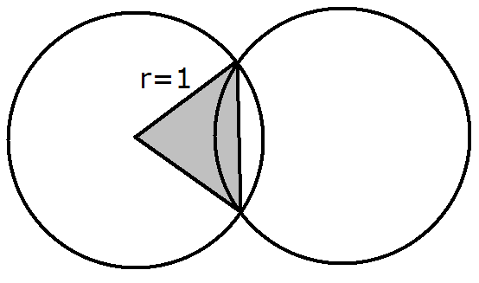
is simply the area of a 60-degree circular sector minus the
area of the equilateral triangle within the sector. This works
out to be $π/6−\sqrt{3}/4$. The hexagon’s area is $\text{54}\sqrt{3}$,
so the final answer is $\text{54}\sqrt{3}+(π/6−\sqrt{3}/4)⋅\text{18}$, which
simplifies to $3π+(\text{99}\sqrt{3})/2$.
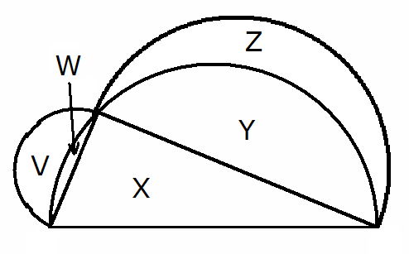
27. A Let 2a be the length of the side of the triangle opposite A, 2b be the side length opposite B, and 2c be the side length opposite C. Thus the semicircles’ radii are a, b, and c, respectively. Now, since the triangle is inscribed in the largest semicircle, and its hypotenuse is a diameter, the angle B must be right. Thus we get (2a) ² + (2c) ² = (2b) ². Dividing through by 8 and multiplying by pi gives ${πa}^{2}/2+{πc}^{2}/2={πb}^{2}/2$. This means that the sum of the two smaller semicircles’ areas equals the
larger semicircle’s area. Now, label the diagram’s regions
as shown. The relationship between the semicircles’ areas
can be written as: (V+W) + (Z+Y) = (W+Y+X), which
simplifies to V+Z = X. Since X = 17, the shaded area is 17.
28. C The equation is so x = 11
29. A The length of the median to the hypotenuse is half the length of the hypotenuse, or 5/2
30. C The number of diagonals of any n-gon is n(n-3)/2. If n=5, then we have (5)(2)/2 = 5.

