Practice With Exponents

Consider a box containing tiles with the number "2" written on each one. Write several expressions for the value of the product of the numbers on these tiles
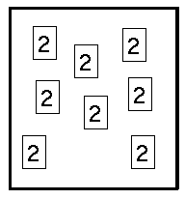

A divider is placed in the box as shown. Fill in the following table.
 | 1 | 2 | 3 | 4 | 5
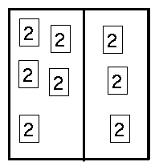 | Exponent Expression for left part | Value of product in left part | Exponent expression for right part | Value of product in right part | Product of columns 2 and 4.
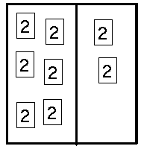

Write a simple rule that explains how to calculate the value in the 5th column
The value in the 5th column is the calculated by multipl
A divider is placed in the box as shown. Using the value in column 1, complete the table for eight tiles and then arrange the tiles so that they match the numbers in the columns.
 | 1 | 2 | 3 | 4 | 5
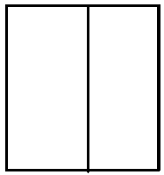 | Exponent Expression for left part | Value of product in left part | Exponent expression for right part | Value of product in right part | Product of columns 2 and 4.

Discussion: How would you complete the table for the following arrangement of tiles?
 | 1 | 2 | 3 | 4 | 5
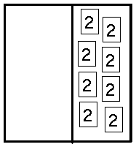 | Exponent Expression for left part | Value of product in left part | Exponent expression for right part | Value of product in right part | Product of columns 2 and 4.

What problems did you have with the final arrangement? What decisions did you make and why?

