Counting
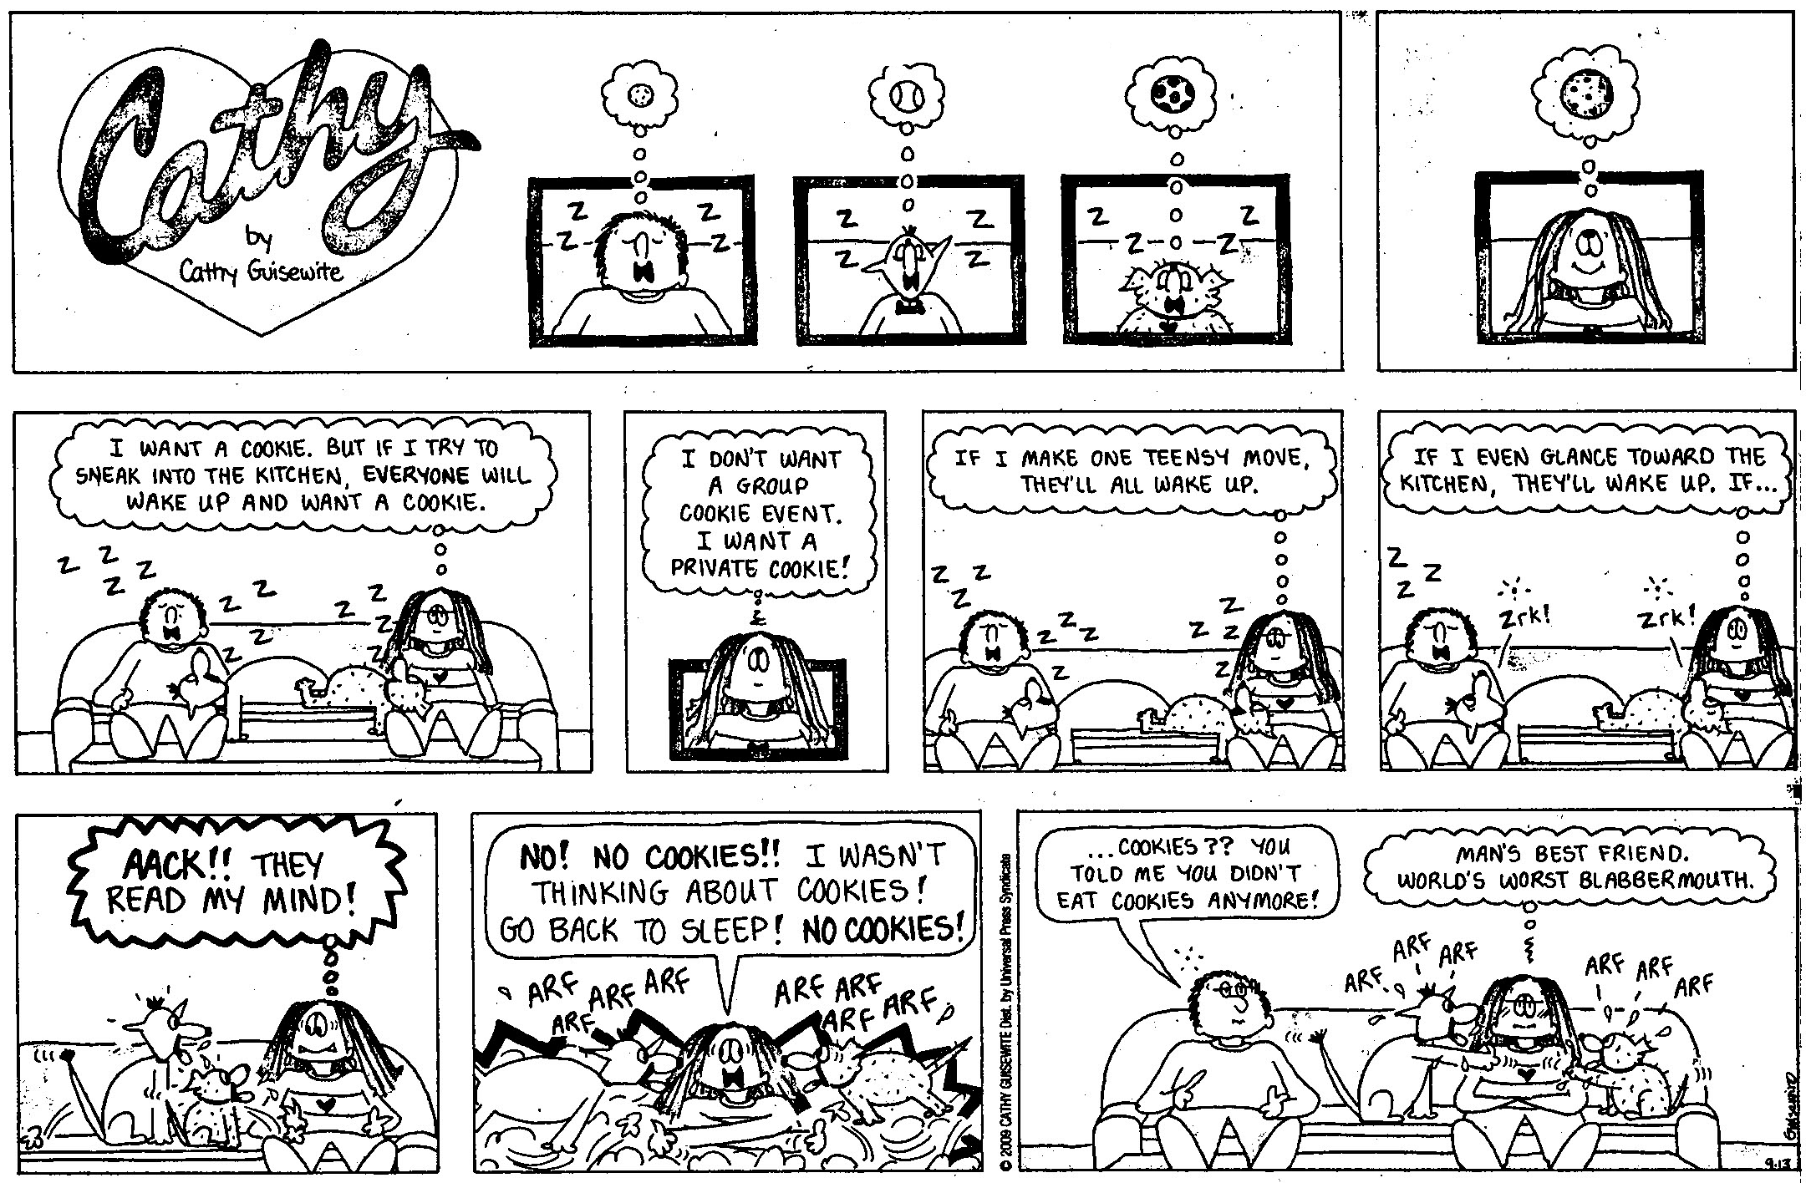

1. Consider the mental state of the man and the dogs in the first frame of the cartoon. What are the objects that are being thought of?

2. If you had to assign a number to these objects, what would it be? Why?

3. In the second frame, the woman also is thinking about a cookie. What number would you assign to that object?

4. What number do you think the man would assign to the cookie? Why?

5. Did you assign the same number to both the man and woman? Is the situation the same for both?

5. What is the woman worried about in frame 3-6?

6. What happened in frame 7? How has the situation about the cookie changed? What has happened to the number of cookies? Are the numbers that you assigned in response 1-4 able to account for the changed situation?

7. Conclusion.

