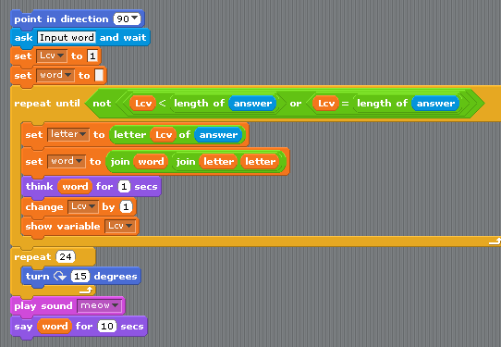
Java | Scratch
Input: Don't know yet | ask (creates variable answer)
lcv = 1 | set
word = "" | set
for (int lcv=1; lcv<= answer.length(); lcv++ | repeat ( length ( answer))
letter = answer.substring(lcv,lcv+1) | set letter to letter (lcv) of answer
word = word + (letter + letter) | set word to word + join(letter,letter)
(debug) System.out.println | think word
lcv ++ | change
(debug) show lcv

