INVERSE FUNCTIONS
Consider the situation where two people view the SAME graph from different perspectives. Bob, the man with the black, hat sees , an increasing curve which is concave up. Walt, the man with the white hat, sees , an increasing curve that is concave down. Each is seeing the INVERSE of what the other sees. (Thus Walt is also seeing ) Bob sees the slope of the point at as . Walt sees the slope of the point at as . Since most of us orient the axes similar to Bob, we would like to give Walt's derivatives in terms of what Bob sees. Thus, poor Walt will have to explain his derivative in terms of things Bob sees. Walt WANTS to calculate . Since Walt's derivative is also the RECIPROCAL of Bob's derivative. Since Bob's derivative is, Walt's derivative is . The trouble is that Walt only knows the number w. Before he can apply the rule for his derivative, he needs to know the value of b. To find this, he must set. This will tell him the x value that is related to his value of w.
Thus, where
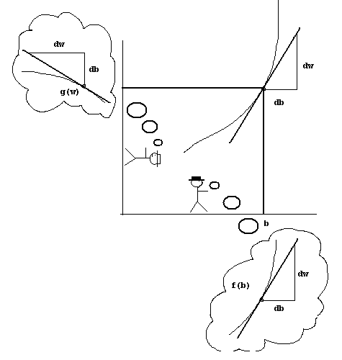
This is what Bob sees.
This is what Walt sees.

