David Essner Exam 1 1981- 1982

1. If a¹⁰ = x² , x > 0, then log_{a} x =
(a) $\sqrt{\text{10}}$ (b) 100 (c) 20 (d) 5 (e) 50

2. In the figure below if BC is parallel to DE, ⏐BC⏐ = 3, ⏐DE⏐ = 4 and ⏐AE⏐ = 10 then ⏐CE⏐ =
(a) 3/2 (b) 2 (c) 5/2 (d) 3 (e) 7/2

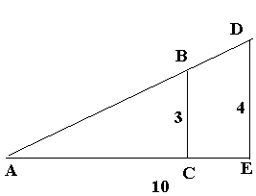

3. If $1.00 is invested at an annual rate of interest of 12% compounded 4 times each year, then after six years the value of the investment, in dollars, is
(a) (1.12)⁶ (b) (1.03)² (c) (1.02)¹⁸ (d) (1.12)⁶ (e) 1.72

4. The sum of all the even integers between 10 and 100 inclusive is
(a) 2500 (b) 2510 (c) 2520 (d) 2530 (e) 2540

5, For a positive integer n the symbol n! means the product of the integers from 1 to n i.e. n! = 1x2x3x...xn. Then n!/(n - 2)! =
(a) n + 2 (b) n² - n (c) n² - 2n (d) n/(n - 2) (e) 2n - 1

6. A student takes 5 exams, each worth 100 points. The average of the first 3 exams was 90 and of all 5 was 88. What was the average of the last two exams?
(a) 80 (b) 82 (c) 84 (d) 85 (e) 86

7. Of the following, which is closest to 2⁴⁰?
(a) 10⁴ (b) 10⁸ (c) 10¹² (d) 10¹⁶ (e) 10²⁰

8. In the xy plane, if the point (x,y) is equidistant from (1,0) and (0,2) then
(a) x² + y² = 5 (b) 2x - 4y + 3 = 0 (c) x² = 2y - 1 (d) (x - 1)² = (y - 2)²
(e) y² = 2(x - 1)

9. Suppose f(x) is a polynomial of degree 5, f(0) = 3, f(1) = 1, f(2) = -1, f(3) = -1/2.
What can we say about the roots of f(x)?
(a) there may not be any (b) there is a negative root (c) there is a root greater than 3 (d) there is a root between 1 and 2 (e) there is a root between 2 and 3

10. Find tan 2θ where θ is an acute angle in a right triangle whose hypotenuse has length 5 and whose side opposite θ has length 3.
(a) 3/2 (b) 3/4 (c) 24/5 (d) 1/5 (e) 24/7

11. A person drives from A to B at 30 miles per hour (mph) and then back without stopping. At what speed must the person drive back to average 35 mph for the trip?
(a) 40 mph (b) not possible (c) 50 mph (d) 42 mph (e) 45 mph

12. Which one of these is a rational number?
(a) $\sqrt{2}$ (b) e (natural exponent base) (c) π (d) e^{πi} (e) $\sqrt{2}$ + $\sqrt{3}$

13. Suppose f(0) = 2, f(1) = 3, f(2) = 4 and for n ≥ 3, f(u) = f(u - 1) - 2f(u - 2) + f(u - 3).
What is f(5)?
(a) -1 (b) 9 (c) 0 (d) 7 (e) impossible to determine from the information given

14. Which of the following polynomials has the property that if r is a root (real or complex) then so is -r?
(a) x⁵ + 3x² + 6 (b) x⁷ - x⁵ + 2x³ - x (c) x⁴ + 2x² + x - 1 (d) x⁴ + x² + x (e) none of (a)-(d)

15. Define the operation (*) by a*b = ab - a - b. Then (3*2)*3 =
(a) 0 (b) -1 (c) 18 (d) 2 (e) none of (a)-(d)

16. The sum of the real values of x for which ⏐x + 2⏐ = 3⏐x - 2⏐ is
(a) 1 (b) 2 (c) 3 (d) 4 (e) 5

17. A 15 ounce mixture of water and alcohol is initially 20% alcohol. Twice 5 ounces of alcohol are added, the solution is mixed, and 5 ounces of the mixture are poured off. How much alcohol will be in the final mixture?
(a) 3 (b) 6 (c) 17 4/5 (d) 13 (e) 8 1/4

18. If C is the center of a circle and A and B are points on the circle so that the area of triangle ABC is 1 and the length of the segment AB is 2, what is the area of the sector ABC?
(a) 3$\sqrt{2}$/4 (b) π/2 (c) $\sqrt{2}$ (d) $\sqrt{3}$ (e) π

19. Ed starts with no money and receives successive payments of $1, $2, $4, $8,... .
Dona starts with $22 and receives $15 each time Ed receives a payment. After how many times will Ed have at least as much money as Dona?
(a) never (b) 10 (c) 6 (d) 7 (e) 8

20. If x is a very large number then $\frac{x^{2}+3x+\text{12}}{2x^{2}+5x+3}$ is
(a) very large (b) very small (c) near 1 (d) near 1/2 (e) near 4

21. When the decimal 0.32121212...is written in lowest terms as a fraction a/b , a > 0, then a + b =
(a) 1321 (b) 1309 (c) 131 (d) 321 (e) 218

22. Suppose a₁ ,a₂, ..., and b₁,b₂, ... are arithmetic progressions with a₁ - b₁= 3 and a₃ - b₃ = 5. What is (a₁ + ... + a₇) - (b₁ ... + b₇)?
(a) 17 (b) 42 (c) 21 (d) 35 (e) 50

23. Suppose ABC is a triangle such that if AD is the median to side BC then ∠ADB = 90° and DB has length 1. What is the area of ABC?
(a) 1 (b) $\sqrt{2}$ (c) $\sqrt{2}$/2 (d) $\sqrt{3}$/2 (e) it is impossible to determine from the given information

24. Which of the following polynomials has the property that the sum of its roots (real or complex) is 6 and the product of its roots is 3?
(a) x³ - 6x² + 3x - 1 (b) x³ - 3x² + 6x - 1 (c) x³ - 6x² + 2x + 3
(d) x³ - 6x² + 2x - 3 (e) x² - 11

25. What is the constant term in the expansion of (x² - 2/x³)⁵ ?
(a) 40 (b) -40 (c) 10 (d) -10 (e) 4

26. S is a square. A circle C is inscribed in S and an equilateral triangle E is inscribed in C. What is the ratio of the area of S to the area of E?
(a) 2 (b) 3 (c) 16/3$\sqrt{3}$ (d) 4 (e) 5$\sqrt{2}$/2

27. If a and b are numbers , when is a³b + ab³ ≥ a⁴ + b⁴ ?
(a) only when a = 0 (b) for all a and b (c) only for a ≥ b (d) only when a = b (e) only for a + b = 1

28. In how many points will the curves x² + 4y² = 4 and y = 3x² – 3 intersect?
(a) 0 or 1 (b) 2 (c) 3 (d) 4 (e) 5 or more

29. Which of the following is the best approximation to (1.0013) ^{1/5} ?
(a) 1.01 (b) 1.0004 (c) 1.0001 (d) 1.00015 (e) 1.0003

30. If x > 1,000,000 which of the following numbers is the largest?

(a) x¹⁰ (b) 10,000,000 x (c) 2^{x} (d) log₁₀ x (e) 40x³ + 80x² + 120x

31. What is the point on the line y = 2x nearest the point (4,21)?
(a) (1,2) (b) (8/5, 16/5) (c) (7/2,3) (d) 2,5) (e) (7/3,14/3)

32. In the figure ABCD is a rectangle with ⏐AD⏐ = 6, ⏐DC⏐ = 8, ⏐DF⏐ = ⏐CG⏐ = ⏐DE⏐ = 3. If H is the midpoint of EF, find ⏐HG⏐.

(a) 7 (b) 8 (c) 2 $\sqrt{\text{14}}$ (d)$\sqrt{\text{178}}$/2 (e) 4$\sqrt{5}$ - 3/$\sqrt{2}$

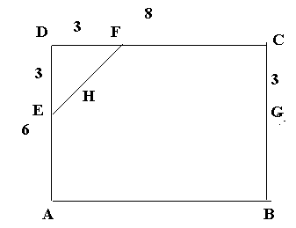
33. $\sqrt{5+2\sqrt{6}}$ - $\sqrt{5−2\sqrt{6}}$ equals
(a) $\sqrt{2}$ (b) $\sqrt{6}$ (c) 2$\sqrt{6}$ (d) 3 (e) 2$\sqrt{2}$

34. If n is an integer, which of the following could not divide both n – 11 and n + 49?
(a) 4 (b) 20 (c) 15 (d) 7 (e) 6

35. Suppose a₁ = 1, a₂ = 3 and, for n ≥ 2, a_{n} = 3a_{n-1} – 2a_{n-2 .} What happens to (a_{n}) ^{1/n} when n gets large?
(a) gets close to 0 (b) gets close to 1 (c) gets close to 2 (d) gets close to 3
(e) gets arbitrarily large

36. If r₁ , r₂, … are the values of x for which x⁸+ 4x⁶ - πx⁴ + 3x² - $\sqrt{2}$ has a minimum, what is r₁ + r₂ + … ?
(a) 0 (b) 1 (c) –1 (d) 2 (e) an irrational number

37. For how many pairs (x,y)of non-negative integers is y² - 2xy = 12?
(a) 0 (b) 1 (c) 2 (d) 3 (e) 5

38. If N is the number of 5 card poker hands which contain exactly one pair (no other pairs or triples) then the highest power of 2 that divides N is
(a) 3 (b) 5 (c) 7 (d) 8 (e) 9

39. A function f is additive if f(x + y) = f(x) + f(y) for all x and y. Consider the 4 functions
f₁ (x) = 3x
f₂ (x) = 2x + 1
f₃ (x) = x²
f₄ (x) = $\sqrt{x}$

Let S be the sum of the k for which f is additive. Then S is
(a) 0 (b)1 (c)3 (d) 8 (e) 10

40. A quantity grows geometrically so that it takes 8 years for the initial amount to quadruple. How many years will it take for the amount to be 8$\sqrt{2}$ times the original amount?
(a) 12 (b) 14 (c) 16$\sqrt{2}$ (d) 20 (e) 24

41. If a and b are positive numbers, let A = $\frac{a+b}{2}$ , B = $\frac{2\text{ab}}{a+b}$, C = $\sqrt{\text{ab}}$. Then (a) A ≥ C ≥ B always (b) A ≥ B ≥ C always (c) C ≥ A ≥ B always
(d) A > B always (e) the order of A,B,C depends on a,b,c

42. In how many zeros does the number 15! ( = 1x2x3x…x15) end when written to the base 14?
(a) 0 (b) 1 (b) 2 (c) 3 (e) 5

43. In the diagram below, length ⏐ABl = 1 and the n angles ∠ΑC₁D₁, D₁C₂D₂, D₂C₃D_{3,…} are right angles and C₁AD₁, C₂D₁D₂,…. are 45° angles. If L = ⏐AC₁ ⏐+ ⏐C₁D₁⏐ + ⏐D₁C₂⏐ + ⏐C₂D₂⏐ + … then
(a) for n large, L is close to 1 (b) if A,D₁,D₂…,B are close together then, for n large, L is close to 1
(c) L = $\sqrt{2}$ (d) for n large, L is large (e) for n large , L is small

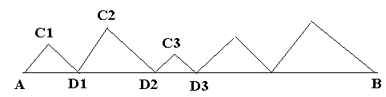

44. In the figure below, if ⏐AB⏐ = 10, angles ∠BAC = 30°, ∠CAD = 45°, ∠ADB = 90° then ⏐AC⏐ =
(a) 5$\sqrt{2}$ (b) 5$\sqrt{3}$ (c) 5($\sqrt{3}$ - 1) (d) 5($\sqrt{2}$ - 1) (e) 5($\sqrt{3}$- $\sqrt{2}$)

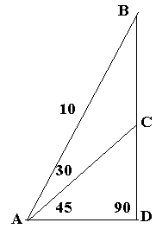

45. In the figure below ABCD is a rectangle and there are the lengths ⏐DE⏐ = 3, ⏐EF⏐ = 2, ⏐FC⏐ = 2, ⏐AG⏐ = 1. What is the length ⏐GH⏐?
(a) 2 (b) 3 (c) 5/2 (d) 12/5 (e) 4
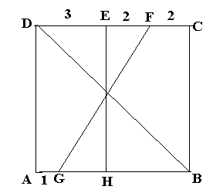

46. Chords AB and CD in a circle are perpendicular and intersect at E. Given the lengths ⏐AE⏐ = 8, ⏐EC⏐ = 4, ⏐ED⏐ =12, then the length of the diameter of the circle is
(a) 8$\sqrt{5}$ (b) 2$\sqrt{\text{65}}$ (c) 4$\sqrt{\text{17}}$ (d) 6$\sqrt{7}$ (e) 12$\sqrt{2}$

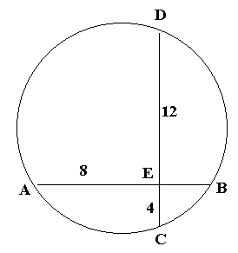
47. ABCD is a quadrilateral inscribed in a circle. Given lengths ⏐AB⏐ = 25, ⏐BC⏐ = 39, ⏐CD⏐ = 52, ⏐AD⏐ = 60 then what is the diameter of the circle?
(a) 65 (b) 45$\sqrt{2}$ (c) 40$\sqrt{3}$ (d) 129/2 (e) $\sqrt{(\text{85})(\text{91})}$

