DAVID ESSNER FINALS XXII 2002-2003

The use of a calculator is permitted only on problems 1(c) and 2. Graphic features of a calculator are not permitted.

I Integers Which Are Both Squares and Cubes Problem

For the purpose of this problem let a positive integer be called dual if it greater than 1 and is the square of a positive integer and also the cube of a positive integer.

(a) Find two dual positive integers.
(b) Find with proof a (necessary and sufficient) condition for an integer to be a dual integer.
(c) (Calculator Problem) Find all dual integers less than 600,000.
(d) Do you think the sum of two dual integers could be a dual integer? Why?

II The Modulo Problem (Calculators not permitted)

In this problem if n is a positive integer then n mod 9 denotes the remainder of the division of n by 9.

- Let m,n be positive integers; prove that if n mod 9 = m mod 9 then
(n + 1) mod 9 = (m + 1) mod 9.

- Let m,n be positive integers. Prove that if 2^{n} mod 9 = 2^{n+ m} mod 9 then 2^{n+1} mod 9 = 2^{n+m+1} mod 9

- What are the possible remainders if n is a positive integer and 2^{n} is divided by 9? Justify your answer.

(d) Using (b) find the value of 2^{420,000,003} mod 9; explain and justify your method of solution. (Calculators NOT permitted)

III The Ice Cream Cone Problem (A calculator problem)
In the figure ABC is an equilateral triangle with sides of length 2 and AB is a diameter of the pictured semicircle. If the arcs AD, DE and EB are equal in length, find
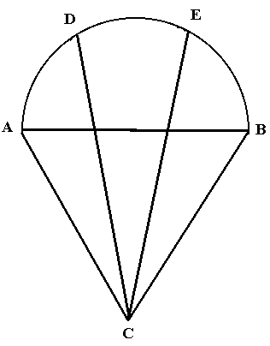
- the measure of angle ∠DCE to the nearest 0.1 degree.
(b) the length of CE to the nearest .001

IV The Basketball Ordered Point Sequence Problem

(a) In 1950 a basketball player could score in two ways –
(i) 2 points for a field goal (ii) 1 point for a free throw

For n = 1,2,3,… let S_{n} denote the number of ordered ways a player could score n points. For example S₄ = 5 since there are the orderings: (1,1,1,1), (1,1,2), (1,2,1), (2,1,1). (2,2).
(a1) Find S₃ and S₅.
(a2) For n > 5 find a method for determining S_{n} from (not necessarily all of) S₁, S₂, … , S_{n-1}. Explain why your method works.
(a3) Find S₁₁ using your method in (a2). Do not try to list the sequences as
there are more than 100.

(b) In the present day a basketball player can score points in three ways:
(i) 3 points for a long field goal (ii) 2 points for a regular field goal
(iii) 1 point for a free throw.
Let T_{n} be the number of ordered ways a player could score n points. For example
T₃ = 4 since there are the four orderings (1,1,1), (2,1), (1,2), (3). Find T₁₁ and explain your method of solution.

V. The Fair Game Gambling Problem

- Players A and B alternately roll a 6 sided die, A going first. The first player to roll a 6 is the winner.
(a1) Find the probability that A wins after A makes 2 or fewer rolls
(a2) Find the probability A is the winner

- Suppose in (a) that A goes first and gets one roll, then B gets two rolls, then A gets one roll, then B gets two rolls continuing so that each time A gets one roll followed by B getting two rolls. What is the probability that A wins?

A gambling game among two or more players is a fair game if each player has equal probability of winning the game.

- Suppose A and B play with a die which is ‘loaded’ such that the probability of rolling a 6 is p. If A goes first and gets one try, then B gets two tries, then A gets one try, then B gets two tries, continuing until there is a winner; find the value of p so that this is a fair game.

- Suppose A and B play with a die which is loaded such that the probability of rolling a 6 is α and the probability of rolling a 5 is β, where 0 < α < β < 1. A and B alternately roll the loaded die, A going first, and each having one roll at their turn. If A rolls a 6 before B rolls a 5 then A is the winner; otherwise B is the winner.
(d1) Find the relationship between α and β in order that this is a fair game.
(d2) Determine the values of α such that there is a value of β to make this a fair
game.

