DAVID ESSNER FINALS XXI 2001-2002

Use of Calculator: Problems (2(e)) and (3) only.

1. The Sum of Three Reciprocals Problem

Given the equation 1/x + 1/y + 1/z = 1:

- If x,y,z are positive integers, find all solutions of the equation.

- If x,y,z are non-zero integers find all solutions in addition to those found in (a).

(In both (a) and (b) you must also prove there are no others).

2. The World Series Problem

Teams A and B play a series of games; in each game either A or B is a winner (there are no ties). The probability that A wins any game is the same regardless of the outcome of the previous games.

- If in each game the probability that A wins is 3/5, find the probability that A wins 2 games before B wins 2 games.

- If in each game the probability that A wins is p, 0 < p < 1, find in terms of p the probability that A wins 2 games before B wins 2 games.

- In (b) find in terms of p the probability that A wins 3 games before B wins 3 games.

(d) For what values of p will the probability of A winning 3 games before B wins 3 games be greater than the probability of A winning 2 games before B wins 2 games? You must prove your answer.

(e) (Calculator Problem) In the baseball world series the first team to win 4 games is the winner. If in each game team A has probability 3/5 of winning the game, find to two decimal places the probability that team A will win the series.

3. The Missile Interceptor Problem (A Calculator Problem)

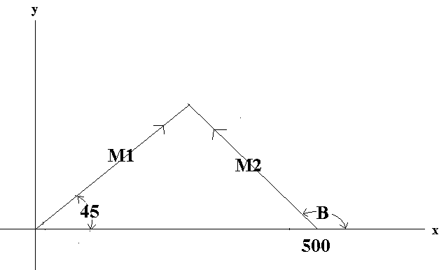
A missile M1 is fired at the origin and travels at a speed of 1000 miles per hour along a straight line (see figure). A second missile M2 is fired at a speed of v miles per hour, and at a position on the positive x axis and a distance of 500 miles from the origin as shown.

- If B = 150° and v = 1500 find, in miles to 4 decimal places, the positions (i.e. (x,y) coordinates) of M1 and M2 one minute after being fired.

(b) If B = 150° and v = 1500 determine to three decimal places at what time in minutes after M1 is fired that M2 must be fired in order to intercept M1.

(c) If B = 150° and M2 is fired after M1, determine to the nearest integer those speeds v for which M2 can be fired at some time to intercept M1.

(d) If v = 1500 determine for which angles B > 90° it is possible for M2 to intercept M1;
express answer to 0.1° accuracy.

- If v = 1500 and M1, M2 are fired at the same time, find B in degrees to 3 decimal places if M2 is to intercept M1. Determine in minutes to 2 decimal places the time after M2 is fired that it intercepts M1.

4. The Divisiblity Problem

(a) Prove that 3n² + 3n + 1 is not divisible by either 3 or 5 for any positive integer n.

- Prove that none of the numbers 2,3,4,5,6 can divide both n³ + 1 and (n + 1)³ + 1 for any positive integer n.

(c) Find three positive integer values of n such that 7 divides both n³ + 1 and (n + 1)³ + 1 and explain how you arrived at your values of n.

- Find all positive integer values of n such that 7 divides both n³ + 1 and (n + 1)³ + 1 .

BONUS PROBLEM

- Show 7 is the only integer greater than 1 which divides both n + 2 and
n² – n + 1 for some positive integer n.

- Show 7 is the only integer greater than 1 which divides both n³ + 1 and (n + 1)³ + 1 for some positive integer n.

5. The Tiling Problem

- Prove that for all positive integers n, 4^{n} – 1 is divisible by 3.

(b) A table is placed on a 1x1 tile in the lower left corner of a 4x4 room (Figure 2). Show that the remainder of the room can be tiled with L shaped tiles ( Figure 1).

(c) If a table is placed on any 1x1 tile in a 4x4 room, show that the remainder of the room can be tiled with L shaped tiles.

(d) Repeat (c) if the table is placed on any 1x1 tile in an 8x8 room.

(e) For every positive integer n, if a table is placed on any 1x1 tile in a room of size 2^{n} x 2^{n} then the remainder of the room can be tiled with L shaped tiles; outline the important ideas in a proof of this.

Figure 1 Figure 2

