DAVID ESSNER FINALS XX 2000-2001

Use of Calculator: Problems 1 and 3(b) only

- THE 72 RULE (Years to Double Value) = 72/(Annual Rate)
(A Calculator Problem)

This problem concerns an investment made at an interest rate of r% compounded annually over t years (t a real number not necessarily an integer).

(a) Given r find a formula in terms of r for the time t required for the value of the investment to double. Using the formula find for r = (a1) 4% (a2) 12% (a3) 18% the number t, to the nearest 0.1 year, required for the value of an investment to double.

(b) The 72 rule says that the number t of years required for an investment at r% compounded annually to double is given by t = 72/r. For each of the cases (a1), (a2), (a3) determine to the nearest 0.1 year the error using the 72 rule.

(c) Given t find a formula in terms of t for the rate r% of interest required to double the value of an investment in t years. (For maximum credit simplify to a formula which does not involve logarithms). Using the formula find to the nearest .01% the value of r for t = (c1) 5 (c2) 10 (c3) 15 years. For each of these cases find to the nearest .01% the error in r using the 72 rule.

(d) In (b) there is a value r = r_{0,} 4 < r₀ < 18, such that the error in t using the 72 rule decreases as r increases from 4 to r₀ and increases as r increases from r₀ to 18. Using a method of approximation (which you must explain) of your own choosing, find to the nearest 0.1% the value of r₀

2. Division by 6 Problem

Prove that for every positive integer n the integer 6 divides the product

(a) n(n + 1)(n + 2)
(b) n(n + 1)(2n + 1)
(c) n(n² + 5)

3. The Inscribed Hexagon Problem

A hexagon is inscribed in a circle of radius r. Find (a) exactly (b) to two decimal places the value of r if two of the sides of the hexagon have length 4 and the other sides have length 3 (as shown in the figure below).
: 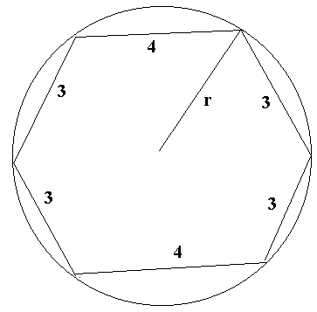

4. The Cereal Box Problem

(a) Each box of Cheaties cereal has 1 of 2 equally likely prizes. A person buys n (n ≥ 2) boxes until getting at least one of each prize. If p_{n} is the probability n boxes are bought find (a1) p₂ (a2) p₃ (a3) p_{n} ( n ≥ 2 arbitrary)

(b) In (a) if there are 3 such equally likely prizes and a person buys n (n ≥ 3) boxes until getting at least one of each prize find (b1) p₃ (b2) p₄ (b3) p_{n} (n ≥ 3 arbitrary)

(c) In (a) if there are 4 such equally likely prizes and a person buys n (n ≥ 4) boxes until getting at least one of each prize find (c1) p₄ (c2) p₅ (c3) p_{n} (n ≥ 4 arbitrary)

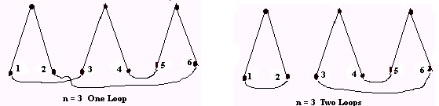
5. The Strings Problem. Start with n pairs of strings, each pair tied at one end.

(a) In how many ways can the strings be tied so that each loose end of each string is tied to exactly one other loose end (a loose end may or my not be may be tied to the other loose end of the string it is paired with)? Do for n = 2,3,4,5 and n arbitrary.

(b) In how many ways can the loose ends be tied so that exactly one loop is formed?
Do for n = 2,3,4,5 and n arbitrary.

(c) In how many ways can the loose ends be tied so that there are exactly two loops formed? Do for n = 3,4,5.

(d) Repeat (c) for 3 loops using values of n =4,5

(e) Repeat (c) for 4 loops using the value n = 5.

(f) Using the values from (a)-(e) complete the table below verifying that the sum of values from (b)-(d) give the totals in (a). Thus rows 1-4 are respectively the values from (b)-(e) and the totals are the values from (a).

number of number of string pairs
loops
1 2 3 4 5

1 1 ___ ___ ___ ___

2 X 1 ___ ___ ___

3 X X 1 ___ ___

4 X X X 1 ___

5 X X X X 1

TOTAL 1 ___ ___ ___ ___

