FINALS EXAM XIX 1999-2000

1. The Gambler’s Problem (A Calculator Problem)

A gambler initially has $D. Each of n consecutive nights he pays $5 to enter a casino, then doubles his remaining money, and then pays $5 for parking. In terms of D how much money does he have after;
(a) 2 nights
(b) 3 nights
(c) n (arbitrary) nights (Express answer in simplified form)
(d) Using (c) find D to the nearest cent if the gambler has $10,000 after 10 nights.

2. The 2^{n} Modulo Problem

If a and b are integers and k > 1 is a positive integer then a ≡ b mod k means that a - b is divisible by k i.e.(a - b)/k is an integer.

(a) For each positive integer n let b(n) be the integer, 0 ≤ b(n) ≤ 2 such that
2^{n} ≡ b(n) mod 3; thus for example b(1) = 2 and b(2) = 1. Describe the function b(n) and prove your answer.

(b) Using your solution to (a) find b if 2¹⁰⁰ ≡ b mod 3 and 0 ≤ b ≤ 2.
(c) For each positive integer n let b(n) be the integer, 0 ≤ b(n) ≤ 4 such that 2^{n} ≡ b(n) mod 5.. Describe the function b(n) and prove your answer.
(d) Using your solution to (c) find b if 2¹⁰⁰ ≡ b mod 5 and 0 ≤ b ≤ 4.
(e) Find b if 2¹⁰⁰ ≡ b mod 7 and 0 ≤ b ≤ 6. Explain the method you used to get your answer; a formal proof is not necessary.

3. The Football Kicker’s Angle Problem
(A Calculator Problem)

(a) In the figure below find tan A in terms of a,b,c..

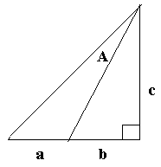

(b) In college football the goal posts are 23 1/3 feet across and are 10 yards behind the goal line. The hashmarks are 5 yards on each side of the goal posts (these are the lines where the ball is placed on out of bound plays – see the Figure below).
If the ball is to be kicked at the 30 yard line (30 yards beyond the goal line) on a hashmark find to the nearest .1 degree the angle determined by the lines from the position of the kicker to the two goal posts.

(c) On what yard line in the middle of the field would the kicker’s angle be the same as the angle found in (b)? Find answer to nearest .1 yard.

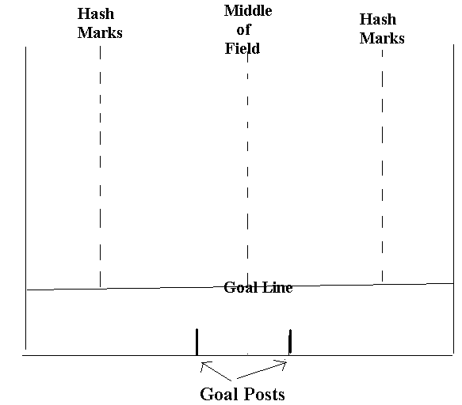

4. The House of a Different Color Problem (A Calculator Problem)
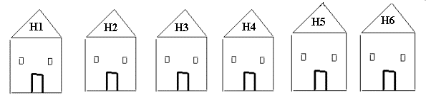
Each of six houses, H₁,H_{2,}...,H₆ , lined in a row, is to be painted with one of three colors, selected at random.

(a) Find the probability no two adjacent houses have the same color.
(b) Assuming no two adjacent houses have the same color,let p_{i}, i = 3,...,6 be the probability that house H_{i} has the same color as house H_{1.} Find each p_{i}.
(c) If the six houses are aligned in a circle, find the probability that no two adjacent houses have the same color.

(d) Repeat (c) if there are 8 houses and four different colors; write the answer to 3 decimal places..

5. The Secret Pal Problem

In a set S_{n} of n persons each is a secret pal of exactly one other person in the group; then xsy will denote that x is the secret pal of y.

(a) Let S₇ = {a,b,c,d,e.f.g} and let the secret pal relation be defined by
{asc,bsf,csg, dsb, esa,fsd, gse}

Find a committee C of 3 persons in the set S₇ such that no person in C is a secret pal of any other person in C. How many such different committees are there?

(b) Let S₁₀ = {a,b,c,d,e,f,g,h,i,j} and let the secret pal relation be defined by
{asc,bsd,csf,dsg,esj,fsa,gsb,hse,ish,jsi}

Find a committee C of 4 persons in the set S₁₀ such that no person in C is a secret pal
of any other person in C. How many such different committees are there? .

Explain why there cannot be a committee C of 5 persons such that no person in the committee is a secret pal of another person in the committee.

(c) Prove that for every secret pal relation on S₁₀ there can be found a committee C of four persons such that no person in C is a secret pal of any other person in C.

(d) For a secret pal relation on a set S₁₀₀ of 100 persons determine the largest possible size for which there must exist a committee C such that no person in C is a secret pal of any other person in C.

