FINAL EXAM XVIII 1998-99

1. (A MONEY PROBLEM)

An amount of $1 is invested at an annual rate of r compounded annually.

(Case 1) After 1 year the original amount plus accumulated interest is withdrawn and the accumulated interest is taxed at a rate t. The effective rate of interest e is then defined to be the rate of interest on the original amount which would have produced the final amount after taxation.
(a) Find e if r = .06 and t = .28.
(b) Find a formula for e in terms of r and t .

(Case 2) After n years the original investment plus accumulated interest is withdrawn and the total amount is reduced by a tax rate of t on the accumulated interest. The effective rate of interest e is defined to be the annual rate of interest on the original amount which if compounded annually would have produced the final amount after the tax reduction.
(d) Find e if r = .06, t = .28 and n = 2.
(e) Find a formula for e in terms of r, t and n .
(f) Find e to three significant digits if r = .06, t = .28 and n = 30.

2. (A BOX PROBLEM)
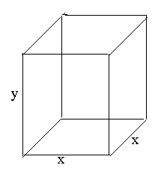
Given a box with square base having length x for its sides and having height y where x and y are positive integers, let V be the volume of the box and A the total area of the six sides.

(a) Find all solution pairs (x,y) of the equation A = V and prove there are no other solutions.
(b) For each of N = 2,3,4,5,6 find all solution pairs (x,y) of the equation A = NV and prove there are no other solutions.
(c) Prove for N a positive integer, N > 6 there are no solution pairs (x,y) of the equation A = NV.

3. (AN AREA PROBLEM)
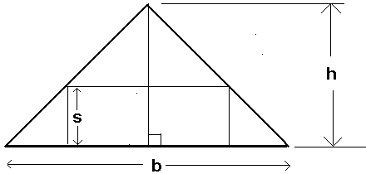

(a) In the pictured figure find the area A of the rectangle in terms of b,h, and s.
(b) In (a) find the maximum area A of the rectangle for given values of h and b. (Note: To get maximum credit do not use calculus).

4. (A CARD SHUFFLE PROBLEM)

(a) A deck of 10 cards, numbered 0,1,2,...,9 is shuffled in the following way: it is "cut" in the middle to produce two decks of 5 cards each which are then combined by alternating the cards of the two decks. The top and bottom cards of the original deck are again top and bottom cards of the shuffled deck. How many shuffles are required to obtain a deck with the same ordering of cards as the original deck? (b) In (a) how many shuffles are required to obtain a deck with the same ordering if the original deck has 52 cards?

5. (A TENNIS PROBLEM)

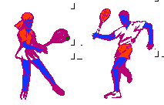

Players A and B play a sequence of tennis points. The first player to win at least 4 points, and at least 2 or more points than the opponent, wins a game. Assume the probability that A wins each point is p, 0 < p < 1. Let W_{n} be the probability that A wins the game after exactly n points.
(a) Find W₄,W_{5,} W_{6,} W₇ and W₈ in terms of p.
(b) Find a formula for W_{n}, n > 8.
(c) Find a formula, in terms of p, that A wins the game; express the answer in closed form (i.e. do not include any infinite sum expressions).
(d) If p = .6 find to 3 decimal places the probability that A wins the game in 8 or less
points.
(e) If p = .6 find the probability to 3 decimal places that A wins a game

