FINALS XV 1995-96

1. In this problem the variables w,x,y denote positive integers. Given the pictured rectangle with sides x and y, and having a border of width w:
(a) If w = 1 find all possible values for x and y, x < y.
(b) If w = 2 find all possible values for x and y, x < y.
(c) For w arbitrary describe in terms of w all possible values for x and y.
(d) Determine all cases, if any, for w,x,y where x = y.

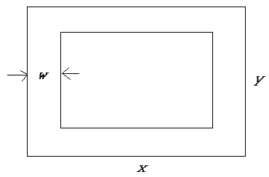
2. Let ABCD be a trapezoid with parallel sides AD and BC perpendicular to side AB. Let E be a point on side AB and a,b respectively the lengths of sides AD and BC, where it is assumed a > b.
(a) Given that triangle CDE is equilateral find the length x of the sides in terms of a and b.
(b) Find a relationship between a and b in order that there exist a point E on side AB such that triangle CDE is equilateral.
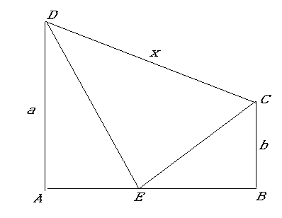

3. In this problem a,b,c,d,k,n denote non-negative integers; a ≡ b mod n means a - b is divisible by n.
(a) Prove if a ≡b mod n and c ≡ d mod n then ac ≡ bd mod n.
(b) Find b, 0 ≤ b ≤ 421 such that 3⁸ ≡ b mod 422
(c) Find b, 0 ≤ b ≤ 421 so that 3¹⁶ ≡ b mod 161.
(d) Suppose k is a positive integer such that the exact value of 3^{k} is out of the range of your calculator. Give an algorithm for finding b, 0 ≤ b ≤ k - 1, so that 3^{k} ≡ b mod k.
(e) Using your algorithm in (c) find b, 0 ≤ b ≤ 421 such that 3⁴²² ≡ b mod 422.

4.(a) An experiment has possible outcomes A or B, where A and B cannot occur simultaneously. If A has probability r and the experiment is repeated until either A or B occurs, find the probability in terms of p and r that A occurs before B.
(b) A bent coin has probability 3/5 heads and 2/5 tails on a given toss. If the coin is repeatedly tossed find the probability that a head followed immediately by a tail (HT) occurs before a tail immediately followed by a head (TH) occurs.
(c ) In (b) find the probability that TH occurs before HH occurs.
(d) In (b) find the probability that HH occurs before HT occurs.
(e) Which is most likely to occur first (and why)?
(i) HT or TH (ii) TH or HH (iii) HH or HT
(f) What is unusual about the conclusions in parts (i), (ii), (iii) of (e)?

5. A monkey climbs a 100 foot greasy pole. It climbs half way to the top and falls 1/4 of the way to the bottom. It then climbs half way to the top from its new position and falls 1/4 of the way to the bottom The climbing continues, each time climbing half of the way to the top from its new position and falling 1/4 of the way to the bottom.
- The monkey is 50 feet high after the first climb; find its height after the second and third climb.
- Find a formula for its height after the n^{th} climb.
- Describe the approximate position of the monkey after the n^{th} climb when n is very large.
- Does the monkey ever reach the top of the pole? Explain.

