FINALS X1 1991-92

1. The (non-negative) integer "triangle" (I) is equilateral since the sum of integers on each side totals the same (i.e. 20)

(a) In "triangle" (II) for which non-negative integers x is it possible to assign values to give an equilateral "triangle" (all values must be non-negative integers)?

(b) In "triangle" (III), p is the center point. Describe all possible cases, if any, for a,b,c,x,y,z,p in order that the "triangle" be equilateral and each altitude have the
same length (i.e. a+p+z = b+p+x = c+p+y). All values must be non-negative integers.

(c) Repeat (b) if the "triangle" is to be isosceles, rather than equilateral, with equal sides ayb and axc and equal length altitudes to these two sides.

*4 ⏐ *2 ⏐ *a
⏐ ⏐
*10 *11 ⏐ * *x ⏐ *y *x
⏐ ⏐ *p
*6 *9 *5 ⏐ *8 * *5 ⏐ *b *z *c

(I) (II) (III)

2. Find all positive integers which, for some positive integer n, can divide each of 5n + 13, 3n + 3, and 2n - 2. (Note: You must find all such integers and prove there are no others).

3. A 2x2 rectangular wall can be filled with 1x2 bricks in two ways:

Sketch all possible ways in which a (a) 3x2 (b) 4x2 rectangular wall can be filled with 1x2 bricks.

(c) Determine the number of ways in which a 4x3 rectangular wall can be filled with 1x2 bricks.

(d) Determine the number of ways in which a 10x2 rectangular wall can be filled with 1x2 bricks.

4. (a) Find numbers a,b,c such that if x = y - a then for all real numbers y:
x³ + 3x² + 6x + 6 = y³ + by + c

(b) Using values of b,c from (a) find numbers A,B,C such that for all real numbers r:

(r + A/r) ³ + b(r + A/r) + c = r³ + B/r³ + C

(c) Find a solution of the equation x³ + 3x² + 6x + 6 = 0. You may introduce new symbols for numeric expressions, and give your answer in terms of the new symbols.

(d) Knowing one solution of the equation in (c), explain how one could obtain all remaining solutions of the equation (do NOT attempt to find the remaining solutions).

5. In the figure, triangle ABC is equilateral with side x, and lines L₁ , L₂ , and L₃ are parallel. If a is the distance between L₁ and L₂ and b the distance between L₂ and L₃
(a > b):
(a) Solve for x in terms of a and b.
(b) If a = 1 and b is very small (near but not equal to 0) then x is near what number? Solve in two ways (i) using the result of (a) and (ii) directly from the figure using elementary geometry.
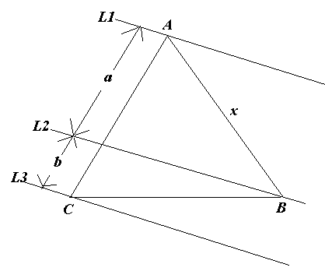

6. Let A = {1,2,3,...,48,49} and B = {1,2,3,...,43,44}:
R = Set of all subsets of B of size 6;
S = Set of all subsets of A of size 6 which do not have two consecutive integers (e.g. S cannot contain such subsets as {2,5,6,28,35,42} since 5,6 are consecutive integers);
T = Set of all subsets of A of size 6;

If r,s,t are respectively the number of elements in R,S,T:
(a) Prove r = s (one method is to create a one-to-one correspondence between R and S).
(b) In the Florida lottery 6 numbers are selected at random from 49 numbers. Express in terms of r and t the probability that a selection of 6 numbers has two numbers which are consecutive.

